


SOFTWARE DESIGN SPECIFICATION
<DOMAIN NAME>
<PROJECT NAME>

Created By: | <Intern Name> | Approved By: | <Domain Lead Name>
Created On: | DD-MMM-YYYY | Approved On: | DD-MMM-YYYY

Page left blank intentionally

INDEX
1 PURPOSE 2
2 PROJECT SCOPE 2
3 SYSTEM OVERVIEW 2
4 DESIGN CONSIDERATIONS 2
4.1 Requirements 3
4.2 Assumptions 3
4.3 Dependencies 3
5 SYSTEM ARCHITECTURE 3
5.1 Architectural Strategies 4
5.2 Structure & Relationships 4
6 DETAILED DESCRIPTION OF COMPONENTS 4
7 INTEGRATION 5
8 APPENDICES 1
8.1 Appendix A – Detailed Description of Components 1

SOFTWARE DESIGN SPECIFICATION
Cal.com Cloud Calendar Management Platform (IP-11803)
General Instructions for using the Live Project POC Document
- This template and the subsequent document created using this template is a confidential document and is the intellectual property of Cloud Counselage Pvt. Ltd. Circulating it outside of the organisation without the consent of Cloud Counselage Pvt. Ltd. is the breach of company policies and will lead to legal actions
- The Design Specification of a software forms the basis of development of software
- The text between inequality (< >) is to be replaced by relevant text
- Please remove the yellow highlight on the Text between the inequality (< >). This is done to help you notice the text to be changed/replaced
- The text in italics highlighted in grey is just for reference and should be removed after adding the relevant text

PURPOSE
This document is created based on the requirement specification document. The purpose of this Software Design Specification (SDS) Document is to describe the detailed architecture, design, and component-level specification for the Cal.com Calendar Management Platform deployed on Amazon Web Services (AWS) for Cloud Counselage Pvt. Ltd. It explains how the open-source Cal.com application is containerized using Docker, orchestrated on AWS ECS with AWS Fargate, backed by AWS RDS PostgreSQL, and exposed securely through an AWS Application Load Balancer with HTTPS certificates managed by AWS Certificate Manager. This document serves as the blueprint that guides the development, testing, and deployment phases of the project and ensures all team members understand the technical design before implementation.

PROJECT SCOPE
The scope of the Cal.com Calendar Management Platform includes its distinct features, its benefits, and its limitations. The system's distinct features allow it to centralize calendar management for the client and his team of 20 members, automate booking workflows with Zoom and Google Meet, prevent double bookings, and secure company data. The platform is deployed on AWS using a highly scalable and cost-effective design: AWS ECS with AWS Fargate for serverless containers, AWS RDS PostgreSQL for fully managed data storage, an AWS Application Load Balancer with AWS Certificate Manager for HTTPS traffic, a fully automated GitHub Actions CI/CD pipeline (.github/workflows/deploy.yml), an auto-scaling policy based on CPU utilization (scale-up above 70% for 3 consecutive minutes, scale-down below 30% for 10 consecutive minutes), and AWS CloudWatch for centralized monitoring and logging. The scope is limited to the open-source Cal.com deployment; custom source-code modifications, mobile application development, and additional platform integrations beyond Zoom and Google Meet are outside the scope of this phase.

SYSTEM OVERVIEW
This section provides an outline of the various components and subsystems of the Cal.com Calendar Management Platform.

The Cal.com Calendar Management Platform is a web-based scheduling system deployed as Docker containers on AWS ECS with AWS Fargate. It comprises the following major subsystems:
1. Cal.com Application - the core open-source scheduling engine that handles user registration, availability, booking, and meeting-type management.
2. Load Balancer Layer - the AWS Application Load Balancer routes incoming HTTPS traffic and manages SSL certificates via AWS Certificate Manager.
3. Database Layer - AWS RDS PostgreSQL stores user profiles, availability, bookings, and meeting metadata with automated backups.
4. CI/CD Pipeline - GitHub Actions (deploy.yml) builds the Docker image, pushes it to Amazon ECR, and updates the ECS tasks on every push to the 'main' branch.
5. Monitoring and Logging - CloudWatch collects metrics and logs (/ecs/calcom-app) to provide centralized visibility of the platform.
6. Auto-scaling - ECS Service Auto Scaling adjusts the number of container tasks based on CPU utilization (scale-up > 70% for 3 min, scale-down < 30% for 10 min).
7. Baseline Automation - an EC2 Ubuntu Server with MongoDB runs a single Bash script that automatically takes a backup of the MongoDB data and converts it into a ZIP file, saved on the local storage of the server (can be shifted to Amazon S3 later).
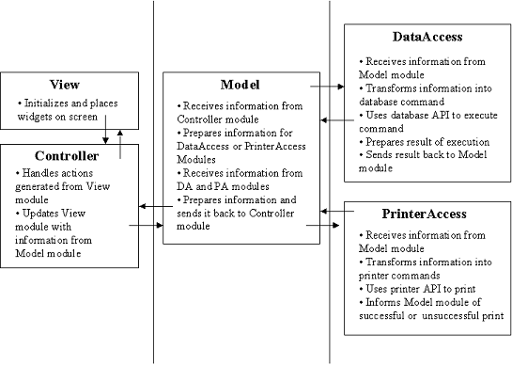
FOR EXAMPLE: DELETE THIS IMAGE BEFORE SUBMITTING

DESIGN CONSIDERATIONS
This section describes requirements, assumptions and dependencies to be addressed to devise a complete design solution.

Requirements
The design must satisfy the functional and non-functional requirements identified in the SRS document:
FR: user registration and login; availability management and booking links; external invitee booking; double-booking prevention; Zoom and Google Meet integration; confirmations and reminders; meeting types; persistence in AWS RDS PostgreSQL; containerized deployment on ECS (Fargate); HTTPS via ALB/ACM; auto-scaling on CPU thresholds; automated CI/CD via GitHub Actions; CloudWatch logging; baseline MongoDB backup POC (single Bash script on EC2 Ubuntu Server converting backups to ZIP on local storage).
NFR: performance for up to 20 concurrent users; scalability; security (HTTPS, restricted database access); reliability through managed AWS services; availability with ALB health checks; maintainability via automated deployments; usability with an intuitive web interface; cost efficiency through a serverless design.

Assumptions
The design assumes: AWS Free Tier/internship credits are available; GitHub Actions, Docker, and Docker Compose are available at no additional cost; Cal.com's open-source license permits commercial deployment; the team has basic AWS and Linux expertise with reliable internet access; the MongoDB backup script on the EC2 Ubuntu Server keeps working and saving backups on local storage; and the client will provide access to Zoom/Google Meet accounts for integration testing.

Dependencies
The design depends on: the AWS environment (ECS, Fargate, RDS, ALB, ACM, ECR, CloudWatch); the GitHub repository with GitHub Actions for CI/CD; Docker images built and pushed to Amazon ECR; Zoom and Google Meet APIs for meeting creation; Cal.com open-source release and its official documentation; and the existing EC2 Ubuntu Server with MongoDB for the baseline backup automation.

SYSTEM ARCHITECTURE
The software system architecture refers to the logical organization of a distributed system into software components. It defines how components of a software system are assembled, their relationship and communication between them. It serves as a blueprint for software application and development basis for developer team. An effective architecture serves as the conceptual glue that holds every phase of the project together for all of its stakeholders, enabling agility, time and cost savings, and early identification of design risks.
The Software architecture:
- Defines structure of a system
- Defines behaviour of a system
- Defines component relationship
- Defines communication structure
- Balances stakeholder’s needs
- Influences team structure
- Focuses on significant elements
- Captures early design decisions

Below some important characteristics which are commonly considered are explained.
Operational Architecture Characteristics:
- Availability
- Performance
- Reliability
- Low fault tolerance
- Scalability

Structural Architecture Characteristics:
- Configurability
- Extensibility
- Supportability
- Portability
- Maintainability

Cross-Cutting Architecture Characteristics:
- Accessibility
- Security
- Usability
- Privacy
- Feasibility

Architectural Strategies
Major components of the system architecture:
1. ECS Fargate Task - runs the Cal.com application container.
2. Application Load Balancer (ALB) - entry point, HTTPS termination.
3. AWS Certificate Manager (ACM) - SSL/TLS certificates.
4. AWS RDS PostgreSQL - primary data store with automated backups.
5. Amazon ECR - Docker image registry.
6. GitHub Actions - CI/CD workflow (deploy.yml).
7. Amazon CloudWatch + CloudWatch Logs - metrics and centralized logs (/ecs/calcom-app).
8. EC2 Ubuntu Server + MongoDB + Bash script - baseline database backup automation (automatic backup converted to ZIP and saved on local storage).

Structure & Relationships
Data and request flow:
User (HTTPS) -> AWS Application Load Balancer (ACM SSL certificate) -> ECS Fargate task (Cal.com container) -> AWS RDS PostgreSQL.
Developer pushes to 'main' branch -> GitHub Actions builds Docker image -> pushes to Amazon ECR -> updates ECS task definition / service.
Amazon CloudWatch collects CPU metrics and application logs (/ecs/calcom-app) for centralized monitoring.
Baseline backup: a single Bash script on the EC2 Ubuntu Server takes a backup of MongoDB data and converts it into a ZIP file saved on local storage (can be shifted to Amazon S3 later).
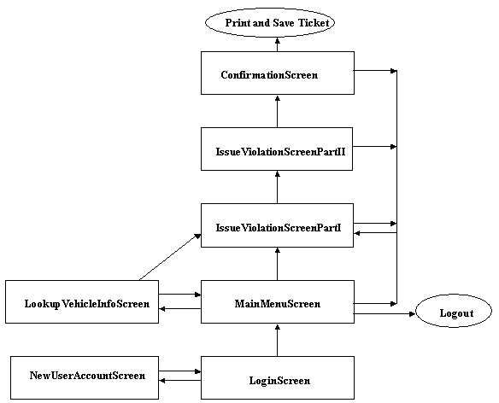
FOR EXAMPLE: DELETE THIS IMAGE BEFORE SUBMITTING

DETAILED DESCRIPTION OF COMPONENTS
For detailed description of the components, please refer Appendix A – Detailed Description of Components

The below template will be used to specify the details of all the components
Table 1: Detailed Design Specification Template
Identification | The unique name for the component and the location of the component in the system.
Type | A module, a subprogram, a form, a data file, a control procedure, a class, etc.
Purpose | Function and performance requirements implemented by the design component, including derived requirements. Derived requirements are not explicitly stated in the SRS - but are implied or adjunct to formally stated SDS requirements.
Subordinates | The internal structure of the component, the constituents of the component, and the functional requirements satisfied by each part.
Dependencies | How the component’s function and performance relate to other components. How this component is used by other components. The other components that use this component. Interaction details such as timing, interaction conditions (such as order of execution and data sharing), and responsibility for creation, duplication, use, storage, and elimination of components.
Interfaces | Detailed description of all external or internal interfaces as well as of any mechanism for communicating through messages, parameters, or common data areas. All error messages and error codes should be identified. All screen formats, interactive messages, and other user interface components (originally defined in the SRS) should be given here.
Resources | A complete description of all resources (hardware or software) external to the component but required to carry out its functions.
Processing | A full description of the functions presented in the Function subsection. Pseudocode can be used to document algorithms, equations, and logic.
Data | For the data internal to the component, describes the representation method, initial values, use, semantics, and format.

INTEGRATIONS
The Cal.com Calendar Management Platform integrates with the following applications and services:
1. Zoom - creates meeting links automatically when a booking is confirmed.
2. Google Meet - generates Google Meet links for confirmed meetings.
3. AWS RDS PostgreSQL - persistent storage for users, availability, and bookings.
4. AWS ALB and ACM - HTTPS access with managed SSL certificates.
5. Amazon ECR - hosts the Docker images built by the CI/CD pipeline.
6. GitHub Actions - automated build and deployment on every push to main.
7. CloudWatch Logs (/ecs/calcom-app) - centralized application and container logs.
8. EC2 Ubuntu Server + MongoDB - baseline backup POC where a single Bash script takes an automatic backup and converts it into a ZIP file on local storage (can be shifted to Amazon S3 later).

APPENDICES

Appendix A – Detailed Description of Components
The tables below describe the detailed design of the core components of the platform.

Identification | Cal.com Application Container (ECS Fargate Task)
Type | Docker container / Application module (deployed as an ECS Fargate task)
Purpose | Runs the open-source Cal.com scheduling application. Handles user registration, login, availability management, booking creation, confirmation emails/reminders, and integration with Zoom and Google Meet. Implements the core functional requirements FR-01 to FR-10 of the SRS.
Subordinates | Composed of the Cal.com web application (Node.js/Next.js) and its internal modules: booking engine, calendar integration module, notification service, and database access layer.
Dependencies | Requires AWS RDS PostgreSQL for persistence, AWS Application Load Balancer for incoming HTTPS traffic, AWS Certificate Manager for SSL, Amazon ECR for the image, and GitHub Actions for deployment. CPU utilization metrics are consumed by ECS Service Auto Scaling.
Interfaces | Inbound: HTTPS requests routed by the ALB. Outbound: connections to RDS PostgreSQL (port 5432, secured by security groups), Zoom and Google Meet APIs, SMTP/notification endpoints. Exposes booking pages and admin dashboard over HTTPS.
Resources | Compute: AWS Fargate vCPU/memory (minimal sizing for a 20-member team). Storage: ephemeral container storage plus managed RDS database. Network: VPC with public and private subnets.
Processing | Receives booking requests, validates availability, prevents double bookings, creates meeting links via Zoom/Google Meet, sends confirmations and reminders, and persists booking records to RDS PostgreSQL. Publishes logs to CloudWatch Logs (/ecs/calcom-app).
Data

Identification | AWS RDS PostgreSQL Database
Type | Managed relational database instance
Purpose | Provides fully managed, secure, and auto-backed-up storage for all platform data: user profiles, availability settings, bookings, meeting types, and system configuration. Implements the data persistence requirements (FR-08) of the SRS.
Subordinates | PostgreSQL database engine with one primary database for the Cal.com schema (users, bookings, availability, credentials, events). Managed backups and snapshots handled by the RDS service.
Dependencies | Receives connections from the Cal.com application container. Depends on the VPC/security group configuration to restrict access to application subnets only. Credentials are supplied through environment variables (.env) / ECS secrets.
Interfaces | Inbound: SQL connections from the ECS Fargate task over port 5432. Outbound: automated backups to Amazon S3-managed storage; metrics and events streamed to CloudWatch for monitoring.
Resources | Compute and storage sized for the 20-member team workload (multi-AZ optional; automated backup retention enabled). Encryption at rest via AWS-managed KMS keys.
Processing | Stores and retrieves booking and user data, enforces relational integrity, and performs automated backups. RDS handles patching, replication, and failover to keep the platform available.
Data

Additional component specifications can be added as required. The tables above cover the application container and the database layers of the platform.

